SECJ 3403 Special Topic in Software Engineering

Sem 2 2021/22

INSTRUCTOR: DR. Shahliza bt Abd Halim
shahliza@utm.my

06 May 2022: Compute and Storage
There are different ways of implementing compute services in AWS
i. Compute using EC2 (IaaS) - You have lots of control in configuring the compute service for EC2.
ii. Compute using containerized service (PaaS); Compute using AWS Beanstalk (PaaS)
iii. Compute using AWS Lambda serverless compute(FaaS) - use functions in Lambda to start services and stop unwanted services
However in this lecture, we will only concentrate on EC2 compute services
There are also different types of extra network storage in AWS which are S3, EBS and EFS. For storage lab, we will focus on only EBS as storage.
- Lecture Notes EC2 <<ppt>>
- Lecture Notes Storage <<ppt>>
- Lab for this week <<all labs will be in AWS Learning Academy >>
i. Lab EC2 - refer to Lab 3 Introduction to Amazon EC2
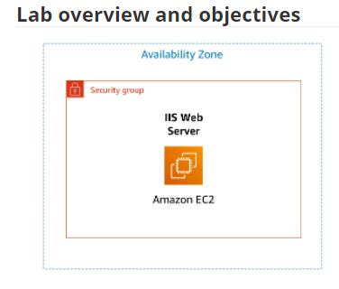
ii. Lab S3 - Lab 4 - Working with EBS
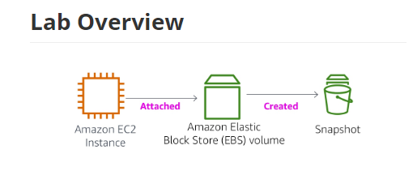
Lab Reflection template (7.5%) : URL will be distributed to each team in team chat. Submission due date: 13th May 2022 before 11.59pm
Exit Ticket : URL will be given in general chat Discord

